**cv. 09 – Experimenty MLP s LFI**

**Kováč, Kurnas**

**Topológia**

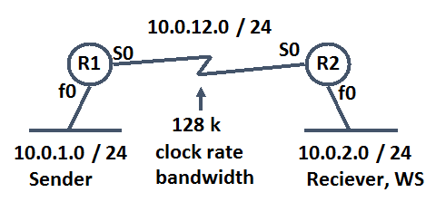

**Toky**

Pre úlohu 1 - vygenerujte 2 UDP toky cez D-ITG:

* hlasový tok: konštantný, intenzita 50 pak/s; veľkosti paketov: konšt., 160B telo (s hlavičkami 218B)
  + využite možnosť v D-ITG vybrať application – Voice s kodekom G.711 (2 samples per packet)
* dátový tok: náhodný – exponenciálny, intenzita 6 pak/s; veľkosť paketov: konštantná, 700B

Pre úlohu 2 – preneste 1 súbor cez TFTP z PC1 na PC2, D-ITG nám netreba

**ÚLOHA 1**

1. **Scenár:** 1 linka, bez použitia LFI aj bez prioritizácie pre VoIP pakety, iba encapsulation ppp

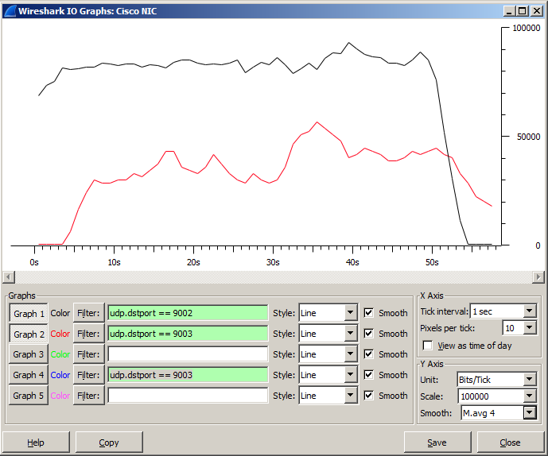

Čierna krivka – hlas

Červená krivka – dáta

**Výpis z D-ITG**

ITGDec version 2.8.1 (r1023)

Compile-time options:

----------------------------------------------------------

Flow number: 1

From 10.0.1.2:55769

To 10.0.2.2:9002

----------------------------------------------------------

Total time = 51.105000 s

Total packets = 2500

Minimum delay = 343.052000 s

Maximum delay = 344.505000 s

Average delay = 343.886928 s

Average jitter = 0.009642 s

Delay standard deviation = 0.372514 s

Bytes received = 430000

Average bitrate = 67.312396 Kbit/s

Average packet rate = 48.918892 pkt/s

Packets dropped = 0 (0.00 %)

Average loss-burst size = 0.000000 pkt

----------------------------------------------------------

----------------------------------------------------------

Flow number: 2

From 10.0.1.2:55770

To 10.0.2.2:9003

----------------------------------------------------------

Total time = 50.568000 s

Total packets = 324

Minimum delay = 343.001000 s

Maximum delay = 344.177000 s

Average delay = 343.711960 s

Average jitter = 0.027372 s

Delay standard deviation = 0.291660 s

Bytes received = 226800

Average bitrate = 35.880399 Kbit/s

Average packet rate = 6.407214 pkt/s

Packets dropped = 0 (0.00 %)

Average loss-burst size = 0.000000 pkt

----------------------------------------------------------

1. **Scenár:** 1 linka, bez použitia LFI ale už s prioritizáciou pre VoIP pakety (policy map – priority 90 [kbps])

* Vytvorte triedu ZAKAZNIK, do ktorej zaradíte všetky hlasové pakety
* Vytvorte politiku PRIORITApreHLAS, ktorou budete prioritizovať pakety triedy ZAKAZNIK pre 90 kbps (priority 90)

class-map match-all ZAKAZNIK

match access-group 101

policy-map PRIORITApreHLAS

class ZAKAZNIK

priority 90

interface Multilink1

ip address 10.0.12.1 255.255.255.0

ppp multilink

ppp multilink group 1

service-policy output PRIORITApreHLAS

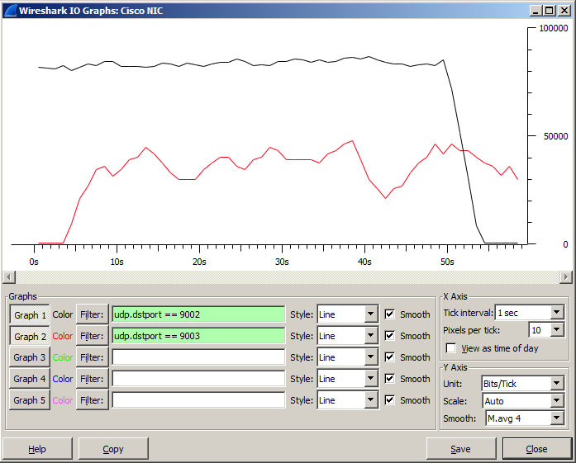

Čierna krivka – hlas

Červená krivka – dáta

**Výpis z D-ITG**

ITGDec version 2.8.1 (r1023)

Compile-time options:

----------------------------------------------------------

Flow number: 1

From 10.0.1.2:61854

To 10.0.2.2:9002

----------------------------------------------------------

Total time = 51.363000 s

Total packets = 2500

Minimum delay = 347.433000 s

Maximum delay = 348.842000 s

Average delay = 348.235887 s

Average jitter = 0.008975 s

Delay standard deviation = 0.383209 s

Bytes received = 430000

Average bitrate = 66.974281 Kbit/s

Average packet rate = 48.673169 pkt/s

Packets dropped = 0 (0.00 %)

Average loss-burst size = 0.000000 pkt

----------------------------------------------------------

----------------------------------------------------------

Flow number: 2

From 10.0.1.2:61855

To 10.0.2.2:9003

----------------------------------------------------------

Total time = 51.044000 s

Total packets = 325

Minimum delay = 349.282000 s

Maximum delay = 350.869000 s

Average delay = 350.116203 s

Average jitter = 0.054670 s

Delay standard deviation = 0.377463 s

Bytes received = 227500

Average bitrate = 35.655513 Kbit/s

Average packet rate = 6.367056 pkt/s

Packets dropped = 0 (0.00 %)

Average loss-burst size = 0.000000 pkt

----------------------------------------------------------

**R1(config-if)#**do sh policy-map int mul 1

Multilink1

Service-policy output: PRIORITApreHLAS

queue stats for all priority classes:

Queueing

queue limit 64 packets

(queue depth/total drops/no-buffer drops) 0/0/0

(pkts output/bytes output) 7500/1515000

Class-map: ZAKAZNIK (match-all)

7500 packets, 1515000 bytes

5 minute offered rate 0000 bps, drop rate 0000 bps

Match: access-group 101

Priority: 90 kbps, burst bytes 2250, b/w exceed drops: 0

Class-map: class-default (match-any)

1027 packets, 709739 bytes

5 minute offered rate 0000 bps, drop rate 0000 bps

Match: any

queue limit 64 packets

(queue depth/total drops/no-buffer drops) 0/0/0

(pkts output/bytes output) 1027/709739

1. **Scenár:** 1 linka, s použitím LFI a prioritizáciou pre VoIP pakety (policy map – priority 90 [kbps])

* Ponecháme policy-mapu
* Pre multilink PPP dokonfigurujeme:
* fragmentáciu paketov na 200B (VoIP to fragmentovať nebude, lebo tie už máme 200 B)
* a ich prekladanie (interleave)

interface Multilink1

ppp multilink interleave

ppp multilink fragment size 200

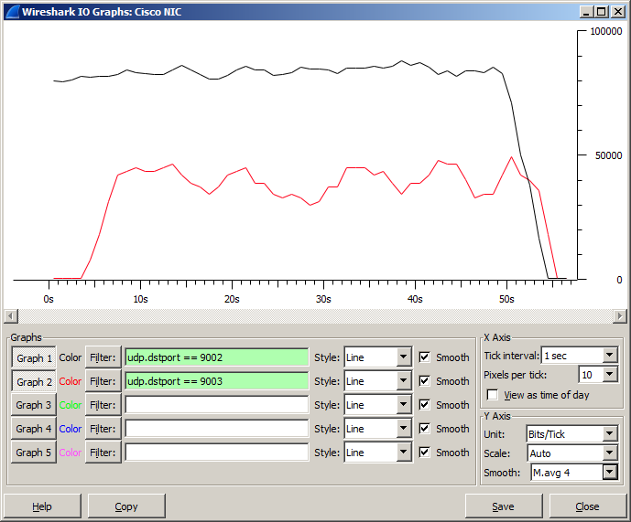

Čierna krivka – hlas

Červená krivka – dáta

**Výpis z D-ITG**

ITGDec version 2.8.1 (r1023)

Compile-time options:

----------------------------------------------------------

Flow number: 1

From 10.0.1.2:51867

To 10.0.2.2:9002

----------------------------------------------------------

Total time = 51.310000 s

Total packets = 2500

Minimum delay = 343.358000 s

Maximum delay = 344.715000 s

Average delay = 344.177691 s

Average jitter = 0.007206 s

Delay standard deviation = 0.347493 s

Bytes received = 430000

Average bitrate = 67.043461 Kbit/s

Average packet rate = 48.723446 pkt/s

Packets dropped = 0 (0.00 %)

Average loss-burst size = 0.000000 pkt

----------------------------------------------------------

----------------------------------------------------------

Flow number: 2

From 10.0.1.2:51868

To 10.0.2.2:9003

----------------------------------------------------------

Total time = 44.613000 s

Total packets = 300

Minimum delay = 343.313000 s

Maximum delay = 345.379000 s

Average delay = 344.077017 s

Average jitter = 0.078819 s

Delay standard deviation = 0.397075 s

Bytes received = 210000

Average bitrate = 37.657185 Kbit/s

Average packet rate = 6.724497 pkt/s

Packets dropped = 0 (0.00 %)

Average loss-burst size = 0.000000 pkt

----------------------------------------------------------

1. **Scenár:** 2 linky, s použitím LFI a prioritizáciou pre VoIP pakety

* Zapojte aj druhú sériovú linku, a pridajte ju do zväzku multilink PPP

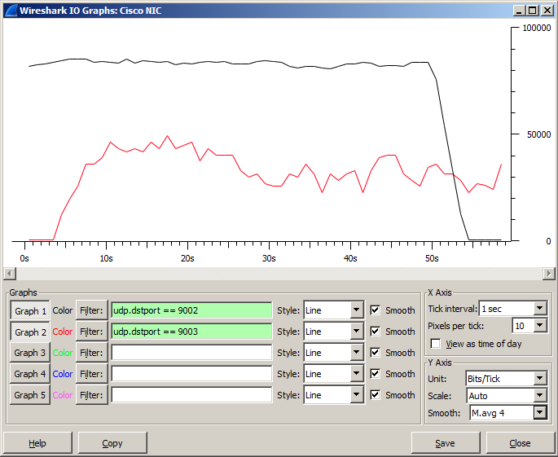

**Výpis z D-ITG**

ITGDec version 2.8.1 (r1023)

Compile-time options:

----------------------------------------------------------

Flow number: 1

From 10.0.1.2:53116

To 10.0.2.2:9002

----------------------------------------------------------

Total time = 51.510000 s

Total packets = 2500

Minimum delay = 341.951000 s

Maximum delay = 343.492000 s

Average delay = 342.603251 s

Average jitter = 0.004406 s

Delay standard deviation = 0.470770 s

Bytes received = 430000

Average bitrate = 66.783149 Kbit/s

Average packet rate = 48.534265 pkt/s

Packets dropped = 0 (0.00 %)

Average loss-burst size = 0.000000 pkt

----------------------------------------------------------

----------------------------------------------------------

Flow number: 2

From 10.0.1.2:53117

To 10.0.2.2:9003

----------------------------------------------------------

Total time = 51.719000 s

Total packets = 304

Minimum delay = 341.808000 s

Maximum delay = 343.591000 s

Average delay = 342.499375 s

Average jitter = 0.013304 s

Delay standard deviation = 0.510106 s

Bytes received = 212800

Average bitrate = 32.916336 Kbit/s

Average packet rate = 5.877917 pkt/s

Packets dropped = 0 (0.00 %)

Average loss-burst size = 0.000000 pkt

----------------------------------------------------------

**ÚLOHA 2**

Meranie času, za ktorý sa prenesie 1 MB súbor cez 1, 2 alebo 3 linky s využitím multilink PPP.

**Generovaný tok:** pošlite súbor cez TFTP z PC1 na PC2, veľkosti do 5 MB, aby ste nemuseli dlho čakať na prenos (použili sme súbor o veľkosti 2,37 MB).

1. **Scenár:** Prepoj cez 1 sériovú linku medzi R1 a R2

* Jedno fyzické rozhranie bude v group 1

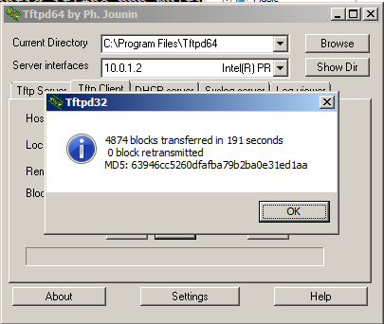

1. **Scenár:** Prepoj cez 2 sériové linky medzi R1 a R2

* Obe fyzické sériové rozhrania budú v group 1

